AI ASSISTED CODING (ASSIGNMENT-11.1)

Name: G.Sai Kiran
Roll No: 2503A52713
Batch: 24

#Q1
Task: Use AI to generate a Stack class with push, pop, peek, and is_empty
methods.
Sample Input Code:
class Stack:
pass
Prompt: generate a code on Stack class with push, pop, peek, and is_empty
methods.
Code:
class Stack:
def __init__(self):
self.items = []
def push(self, item):
self.items.append(item)
def pop(self):
if self.is_empty():
return None
return self.items.pop()
def peek(self):
if self.is_empty():
return None
return self.items[-1]

def is_empty(self):
return len(self.items) == 0
stack = Stack()
stack.push(10)
stack.push(20)
print("Top element:", stack.peek())
print("Popped element:", stack.pop())
print("Is stack empty?", stack.is_empty())
Output:
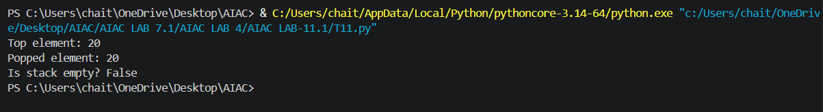

#Q2
Task: Use AI to implement a Queue using Python lists.
Sample Input Code:
class Queue:
pass
Prompt: generate a code to implement a Queue using python list.
Code:
class Queue:
def __init__(self):
self._items = []
def enqueue(self, item):
"""Add an item to the rear of the queue."""
self._items.append(item)
def dequeue(self):

if self.is_empty():
return None
return self._items.pop(0)
def peek(self):
if self.is_empty():
return None
return self._items[0]
def is_empty(self):
return len(self._items) == 0
if __name__ == "__main__":
queue = Queue()
print("Is queue empty?", queue.is_empty())
queue.enqueue(10)
queue.enqueue(20)
queue.enqueue(30)
print("Queue after enqueueing 10, 20, 30:", queue._items)
print("Front item:", queue.peek())
print("Dequeued item:")
print(queue.dequeue())
print("Front item after dequeue:", queue.peek())
print("Is queue empty?", queue.is_empty())
output:
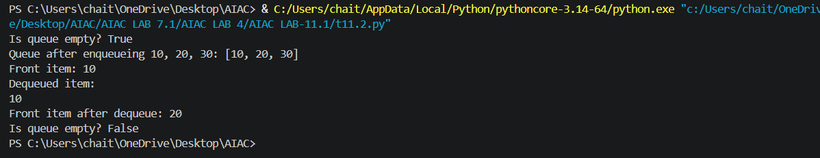
#Q3
Task: Use AI to generate a Singly Linked List with insert and display
methods.
Sample Input Code:
class Node:
pass
class LinkedList:
pass
Prompt: generate a code on singly linked list with insert and display methods.
Code:
class Node:
def __init__(self, data):
self.data = data
self.next = None
class LinkedList:
def __init__(self):
self.head = None
def insert(self, data):
new_node = Node(data)
if self.head is None:
self.head = new_node
return
current = self.head
while current.next is not None:
current = current.next
current.next = new_node
def display(self):
current = self.head
values = []

while current is not None:
values.append(str(current.data))
current = current.next
print(" -> ".join(values) if values else "The list is empty.")
if __name__ == "__main__":
linked_list = LinkedList()
linked_list.insert(10)
linked_list.insert(20)
linked_list.insert(30)
print("Linked list:")
linked_list.display()
ouput:
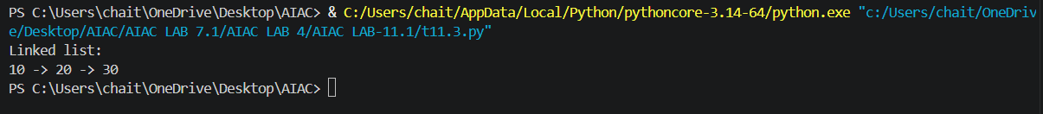
#Q4
Task: Use AI to create a BST with insert and in-order traversal methods.
Sample Input Code:
class BST:
pass
Prompt: generate a code on BST with insert and in-order traversal methods.
Code:
class Node:
def __init__(self, data):
self.data = data
self.left = None
self.right = None
class BST:
def __init__(self):
self.root = None
def insert(self, data):
"""Insert a value into the tree."""
self.root = self._insert(self.root, data)
def _insert(self, node, data):
if node is None:
return Node(data)
if data < node.data:
node.left = self._insert(node.left, data)
elif data > node.data:
node.right = self._insert(node.right, data)
return node
def in_order(self):
values = []
self._in_order(self.root, values)
return values
def _in_order(self, node, values):
if node is not None:
self._in_order(node.left, values)
values.append(node.data)
self._in_order(node.right, values)
if __name__ == "__main__":
bst = BST()
for value in (50, 30, 70, 20, 40, 60, 80):
bst.insert(value)
print("In-order traversal:", bst.in_order())
output:
#Q5
Task: Use AI to implement a priority queue using Python’s heapq
module.
Sample Input Code:
class PriorityQueue:
pass
Prompt: generate a code to implement a priority queue using Python’s heapq
module.
Code:
import heapq

class PriorityQueue:
def __init__(self):
self._items = []

def insert(self, item):
"""Add an item to the priority queue."""
heapq.heappush(self._items, item)

def remove(self):
"""Remove and return the item with the highest priority."""
return heapq.heappop(self._items)

def peek(self):
"""Return the highest-priority item without removing it."""
return self._items[0]

def is_empty(self):
return len(self._items) == 0

if __name__ == "__main__":
queue = PriorityQueue()
for item in (5, 1, 3, 2, 4):
queue.insert(item)

print("Priority order:", end=" ")
while not queue.is_empty():
print(queue.remove(), end=" ")
output:
#Q6
Task: Use AI to implement a double-ended queue using
collections.deque.
Sample Input Code:
class DequeDS:
prompt: generate a code to implement a double-ended queue using
collections.deque.
code:
from collections import deque
class DoubleEndedQueue:
"""A double-ended queue (deque)."""

def __init__(self):
"""Create an empty deque."""
self._items = deque()

def add_front(self, item):
"""Add an item to the front of the deque."""
self._items.appendleft(item)

def add_rear(self, item):
"""Add an item to the rear of the deque."""
self._items.append(item)

def remove_front(self):
"""Remove and return the front item, or None if empty."""
if self.is_empty():
return None
return self._items.popleft()

def remove_rear(self):
"""Remove and return the rear item, or None if empty."""
if self.is_empty():
return None
return self._items.pop()

def is_empty(self):
"""Return True when the deque has no items."""
return len(self._items) == 0

if __name__ == "__main__":
queue = DoubleEndedQueue()

queue.add_rear(10)
queue.add_rear(20)
queue.add_front(5)
print("Deque after adding 10, 20 at the rear and 5 at the front:", queue._items)
print("Removed from front:", queue.remove_front())
print("Removed from rear:", queue.remove_rear())
print("Deque after removals:", queue._items)
print("Is deque empty?", queue.is_empty())
output:
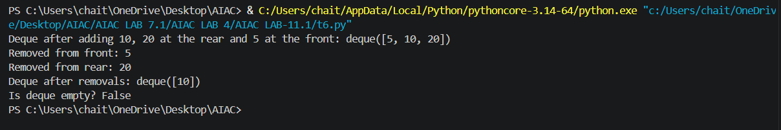
Q7
Task: Real-Time Application Challenge – Choose the
Right Data Structure
Scenario:
Your college wants to develop a Campus Resource Management System
that handles:
1. Student Attendance Tracking – Daily log of students
entering/exiting the campus.
2. Event Registration System – Manage participants in events with
quick search and removal.
3. Library Book Borrowing – Keep track of available books and their
due dates.

4. Bus Scheduling System – Maintain bus routes and stop
connections.
5. Cafeteria Order Queue – Serve students in the order they arrive.
Student Task:
• For each feature, select the most appropriate data structure from
the list below:
o Stack
o Queue
o Priority Queue
o Linked List
o Binary Search Tree (BST)
o Graph
o Hash Table
o Deque
• Justify your choice in 2–3 sentences per feature.
• Implement one selected feature as a working Python program with
AI-assisted code generation.
Expected Output:
• A table mapping feature → chosen data structure → justification.
• A functional Python program implementing the chosen feature
with comments and docstrings.
Prompt: Create a simple Python Event Registration System using a Hash Table (dictionary). Include student registration, searching, deleting, and displaying records using Student ID. Add comments, docstrings, and sample output. Keep the code beginner-friendly and menu-driven.
Code:
"""Simple event registration system backed by a hash table (dictionary)."""

registrations = {}

def register():
"""Register or update a student's event registration."""
student_id = input("Enter Student ID: ").strip()
if not student_id:
print("Student ID cannot be empty.")
return

name = input("Enter Student Name: ").strip()
event = input("Enter Event Name: ").strip()
registrations[student_id] = [name, event]
print("Registration successful!")

def search():
"""Search for a student using Student ID."""
student_id = input("Enter Student ID: ").strip()
if student_id in registrations:
name, event = registrations[student_id]
print("Name:", name)
print("Event:", event)
else:
print("Student not found.")

def remove():
"""Remove a student's registration."""
student_id = input("Enter Student ID: ").strip()
if student_id in registrations:
del registrations[student_id]
print("Registration removed!")
else:
print("Student not found.")

def display():
"""Display all registered students."""
if not registrations:
print("No registrations found.")
return

for student_id, (name, event) in registrations.items():
print(student_id, name, event)

def main():
"""Run the event registration menu."""
while True:
print("\n1. Register")
print("2. Search")
print("3. Remove")
print("4. Display")
print("5. Exit")

choice = input("Enter choice: ").strip()
if choice == "1":
register()
elif choice == "2":
search()
elif choice == "3":
remove()
elif choice == "4":
display()
elif choice == "5":
print("Thank you!")
break
else:
print("Invalid choice")

if __name__ == "__main__":
main()
output:
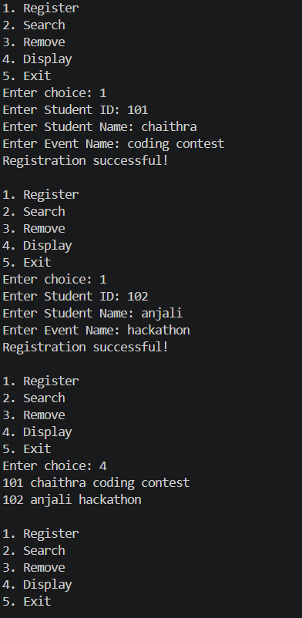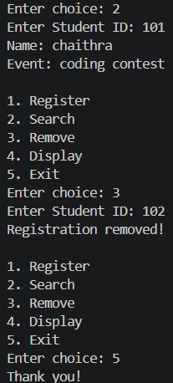
Q8
Task: Smart E-Commerce Platform – Data Structure
Challenge
An e-commerce company wants to build a Smart Online Shopping System
with:
1. Shopping Cart Management – Add and remove products
dynamically.
2. Order Processing System – Orders processed in the order they are
placed.
3. Top-Selling Products Tracker – Products ranked by sales count.

4. Product Search Engine – Fast lookup of products using product ID.
5. Delivery Route Planning – Connect warehouses and delivery
locations.
Student Task:
• For each feature, select the most appropriate data structure from
the list below:
o Stack
o Queue
o Priority Queue
o Linked List
o Binary Search Tree (BST)
o Deque
• Justify your choice in 2–3 sentences per feature.
• Implement one selected feature as a working Python program with
AI-assisted code generation.
Expected Output:
• A table mapping feature → chosen data structure → justification.
• A functional Python program implementing the chosen feature
with comments and docstrings.
Prompt: Create a simple Python Smart E-Commerce System using suitable data structures. Implement shopping cart, order processing, top-selling products, product search, and delivery planning. Add comments, docstrings, and sample output.
Code:
# Smart E-Commerce System
# Data Structure: Deque

from collections import deque

cart = deque()

def add_product(product):
"""Add a product to the shopping cart."""
cart.append(product)
print(product, "added to cart.")

def remove_product():
"""Remove the last product from the shopping cart."""
if cart:
product = cart.pop()
print(product, "removed from cart.")
else:
print("Cart is empty.")

def display_cart():
"""Display all products in the cart."""
print("Shopping Cart:", list(cart))

# Main program
add_product("Laptop")
add_product("Headphones")
add_product("Mouse")

display_cart()

remove_product()

display_cart()
output:
